Kentucky Firefighters Association
Office of the President
Eric Philpot

Greetings to all the fire service in the Commonwealth. On behalf of the Kentucky Firefighters Association Executive Board we would like to announce our support for House Bill 777 as it is written. Representative Ken Fleming (R-Louisville) filed this House Bill to address issues in Emergency Medical Services (EMS). This Bill will improve EMS in Kentucky by ensuring patients receive emergency medical care quickly and efficiently while also helping hospitals handle the needed transfers.

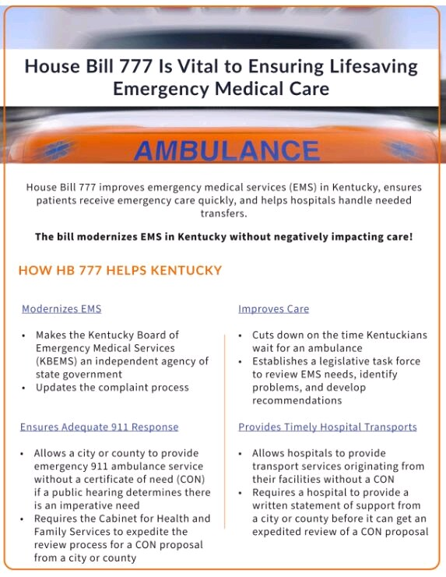

Thank you,

President Eric Philpot

